Chalk’s Landing Property Owners’ Association

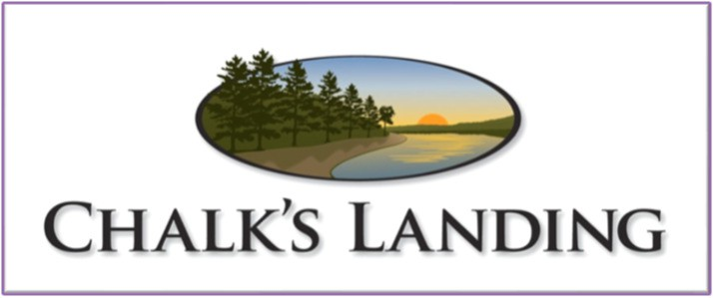
182 Watsons Way, Rockingham, NC 28379 www.chalkslandingpoa.com

Community News, Fall 2022
Save the Date

Chalk’s Point
Chalk’s Point Pavilion is complete and opened officially with a ribbon cutting ceremony at the 2022 annual meeting. It is open to all POA members and their guests when not reserved for a private function. Restrooms can be accessed using the POA gate code.
Chalk’s Landing Board of Directors
Mark DeChant, President Stephen Gerald, Vice-President Maribeth Coller, Treasurer Julie Poplin, Secretary
Gail Harrell, At-Large
The Board can be contacted by email at Board@ChalksLandingPOA.com
Or by phone at 910-434-5540
There have been several birthday parties, twice a month community happy hour, and a wedding. Please see the Chalk’s Landing Webpage for the Events Calendar and amenities policies, procedures, and reservation forms.

Mowing and Landscape
Please join us in giving Gary Weyant a HUGE heartfelt Thank You! He will be retiring from Chalk’s Landing at the end of December after seven plus years of service to the community. He has been responsible for all mowing, miscellaneous landscape activities, and major self-help projects. Most recently, he built the beautiful picnic tables at the Pavilion. The Board is seeking bids for mowing and grounds work to start in 2023.

New Homes under Construction
Three new homes are currently under construction in the neighborhood. Three additional POA members are seeking plan and construction approval. Several lots have changed ownership in the last year or so. WELCOME to our new neighbors!

Website Information
Check out our Chalk’s Landing Website (www.chalkslandingpoa.com) for our By-Laws, Covenants, links to Architectural Review Forms, Events Calendar, and other information.

April 29, 2023
Annual POA Meeting, 2:00 pm

Miscellaneous
Volunteer Opportunities
Please consider serving on the Board or ARC in 2023. Chalk’s Landing can use your experience and expertise. We need YOU!
- Blewett Falls Road between Old Charlotte Highway and Chalk’s Landing is now open.
- Blewett Falls Dam inflatable spillway work is complete. The lake is now back to its full level.
- Gate 1 Inbound opener has been replaced with new Commercial LiftMaster hardware.
- Be advised that a nominal dues increase from $370 to $500 will occur in 2023. This increase is necessary to cover both increased costs and revenue reductions that we have faced over the last few years.

Chalk’s Landing Facebook Page
Our Facebook page is a Closed Group – only POA members can join. It provides a forum for members to share updates and items of interest. To join, go to the following address, request to join, and fill in your lot number when prompted. www.facebook.com/groups/chalkslanding/?ref=share
Our public Facebook page is: https://www.facebook.com/profile.php?id=100070922201834
